**Python Assignment**

Open a new Python interpreter (REPL) and use it to find the value of 2 + 3.

Create a python script to print hello, world! four times.

Create a python script with the following text and see the output.

Write a function istrcmp to compare two strings, ignoring the case.

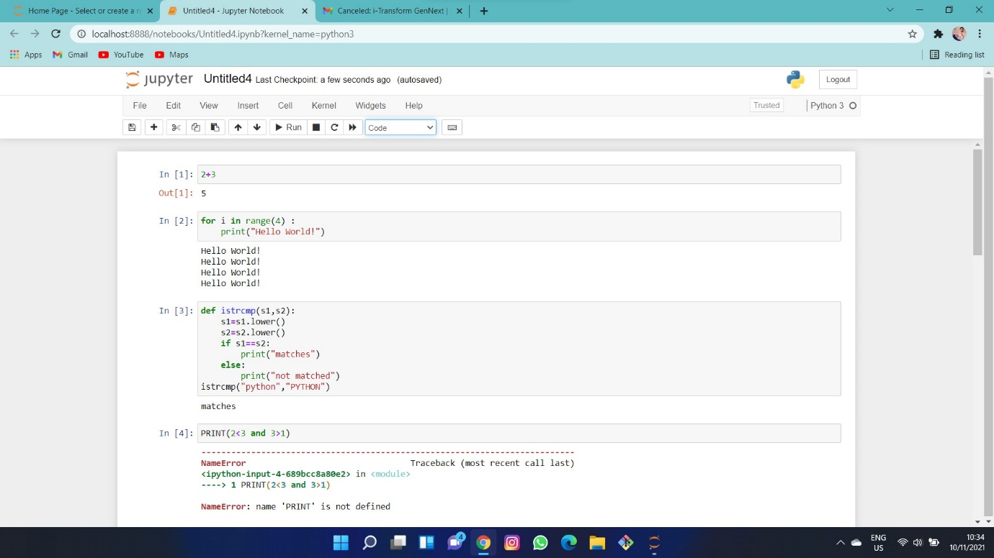

What will be output of the following program?

print (2 < 3 and 3 > 1)

print (2 < 3 or 3 > 1)

print (2 < 3 or not 3 > 1)

print (2 < 3 and not 3 > 1)

What will be output of the following program?

x = 4

y = 5

p = x < y or x < z

print (p)

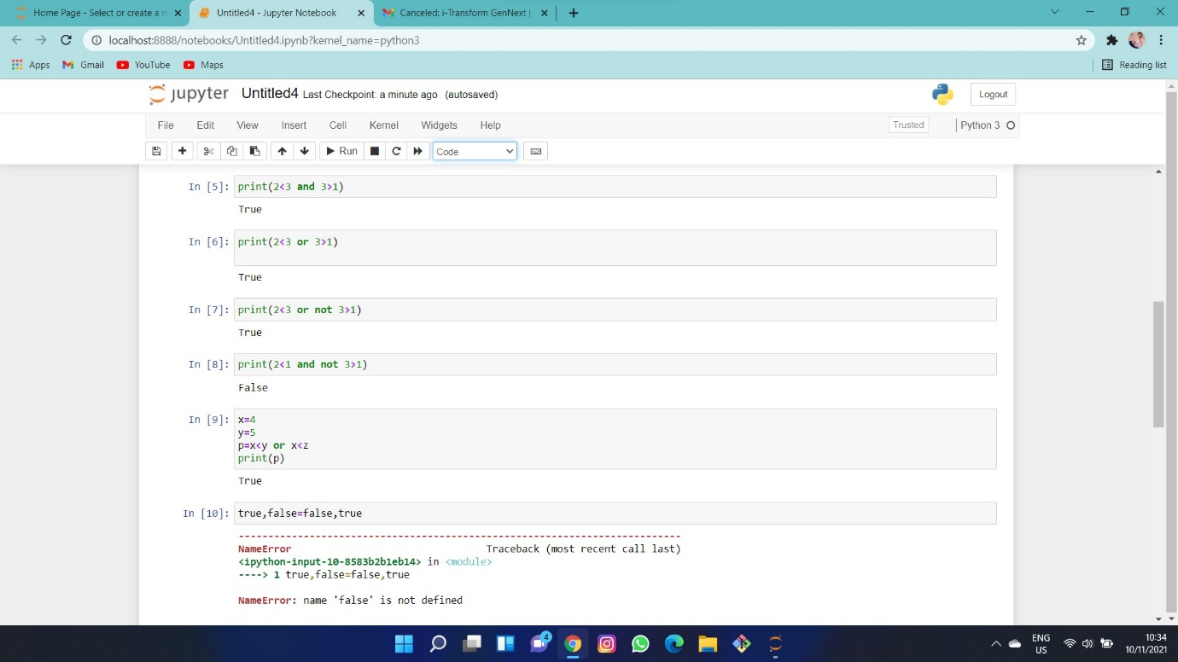

What will be output of the following program?

True, False = False, True

print (True, False)

print (2 < 3)

Question:

Write a function, isharshad that determines whether a number is a Harshad

number (for number base 10).

A Harshad number “is an integer that is divisible by the sum of its digits”

-(Wikipedia)

Example: 81 ? 8 + 1 = 9 ? 81/9 = 9 ? Harshad!

>>> isharshad(81)

True

Hint: convert the number to a string

Question:

Write a program which will find all such numbers which are divisible by 7 but are not a multiple of 5,

between 2000 and 3200 (both included).

The numbers obtained should be printed in a comma-separated sequence on a single line.

Hints:

Consider use range(#begin, #end) method

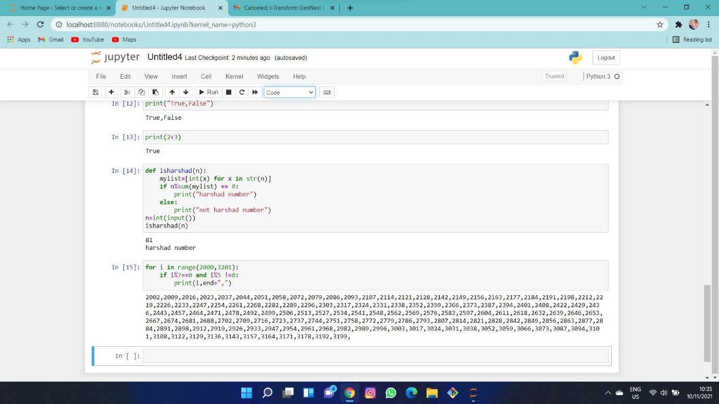

Question:

Write a program which can compute the factorial of a given numbers.

The results should be printed in a comma-separated sequence on a single line.

Suppose the following input is supplied to the program:

8

Then, the output should be:

40320

Hints:

In case of input data being supplied to the question, it should be assumed to be a console input.

Question:

With a given integral number n, write a program to generate a dictionary that contains (i, i*i) such that is an integral number between 1 and n (both included). and then the program should print the dictionary.

Suppose the following input is supplied to the program:

8

Then, the output should be:

{1: 1, 2: 4, 3: 9, 4: 16, 5: 25, 6: 36, 7: 49, 8: 64}

Hints:

In case of input data being supplied to the question, it should be assumed to be a console input.

Consider use dict()

Question:

Write a program which accepts a sequence of comma-separated numbers from console and generate a list and a tuple which contains every number.

Suppose the following input is supplied to the program:

34,67,55,33,12,98

Then, the output should be:

['34', '67', '55', '33', '12', '98']

('34', '67', '55', '33', '12', '98')

Hints:

In case of input data being supplied to the question, it should be assumed to be a console input.

tuple() method can convert list to tuple

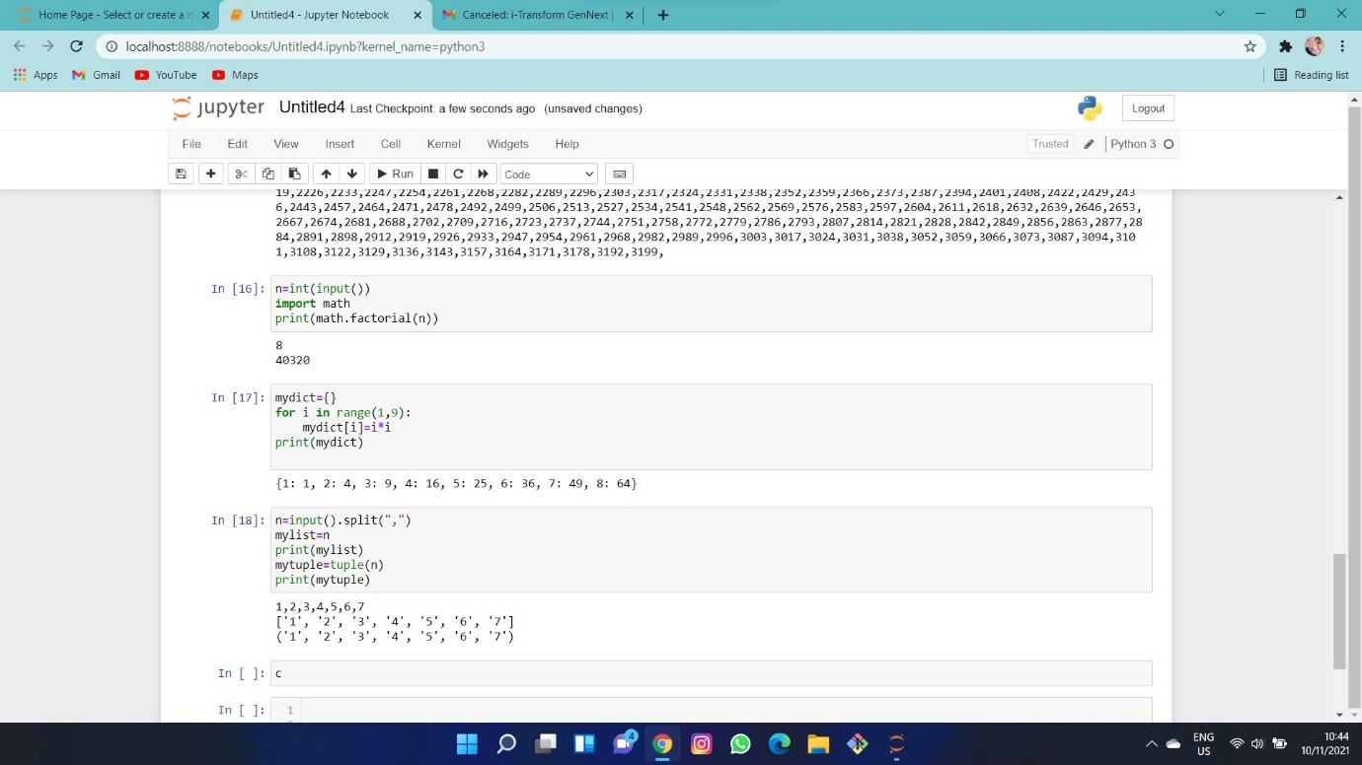

Question:

Define a class which has at least two methods:

getString: to get a string from console input

printString: to print the string in upper case.

Also please include simple test function to test the class methods.

Hints:

Use __init__ method to construct some parameters

Question:

Write a program that calculates and prints the value according to the given formula:

Q = Square root of [(2 * C * D)/H]

Following are the fixed values of C and H:

C is 50. H is 30.

D is the variable whose values should be input to your program in a comma-separated sequence.

Example

Let us assume the following comma separated input sequence is given to the program:

100,150,180

The output of the program should be:

18,22,24

Hints:

If the output received is in decimal form, it should be rounded off to its nearest value (for example, if the output received is 26.0, it should be printed as 26)

In case of input data being supplied to the question, it should be assumed to be a console input.

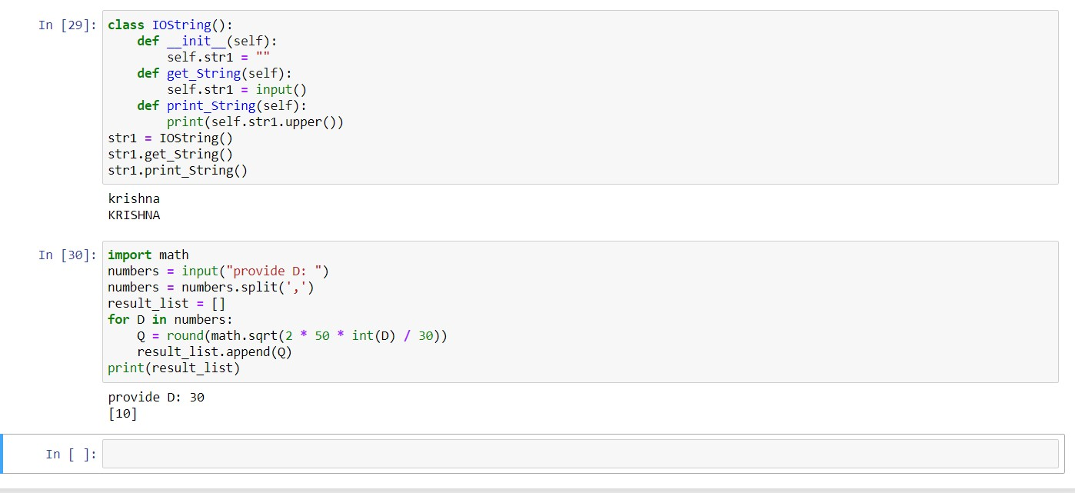

Write a program that accepts a comma separated sequence of words as input and prints the words in a comma-separated sequence after sorting them alphabetically.

Suppose the following input is supplied to the program:

Without , hello ,bag ,world

Then, the output should be:

Bag ,hello, without, world

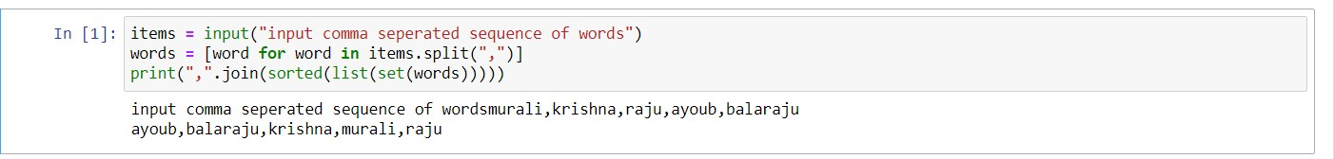

Write a program that accepts sequence of lines as input and prints the lines after making all characters in the sentence capitalized.

Suppose the following input is supplied to the program:

Hello world

Practice makes perfect

Then, the output should be:

HELLO WORLD

PRACTICE MAKES PERFECT

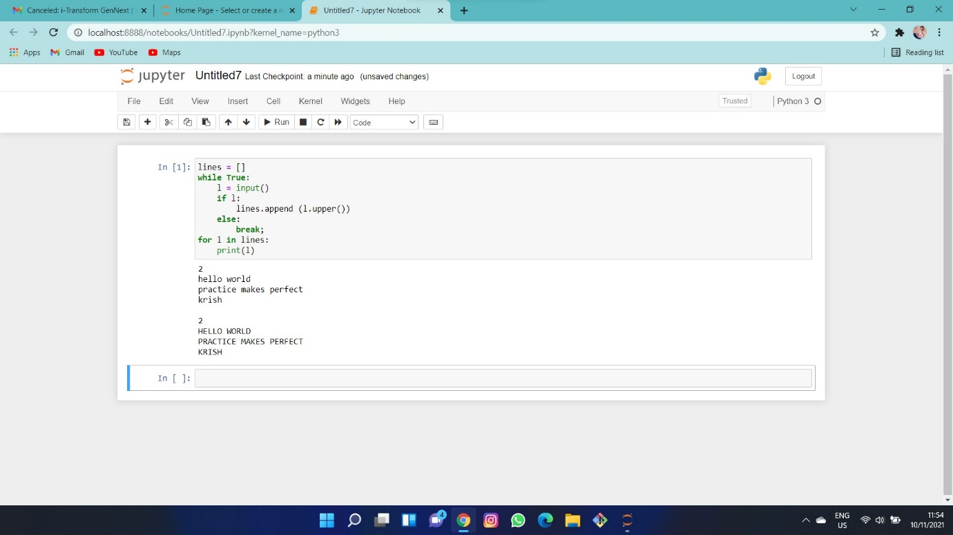

Write a program that accepts a sequence of whitespace separated words as input and prints the words after removing all duplicate words and sorting them alphanumerically.

Suppose the following input is supplied to the program:

hello world and practice makes perfect and hello world again

Then, the output should be:

again and hello makes perfect practice world

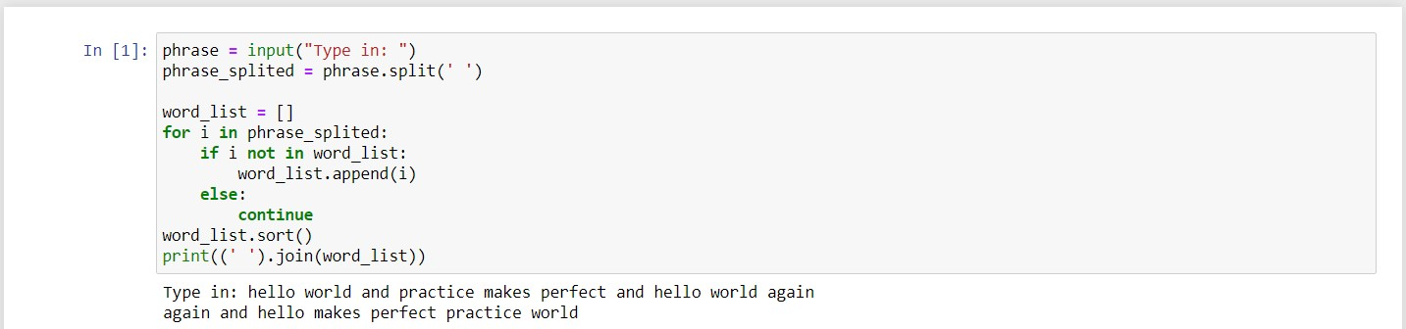

Write a program which accepts a sequence of comma separated 4 digit binary numbers as its input and then check whether they are divisible by 5 or not. The numbers that are divisible by 5 are to be printed in a comma separated sequence.

Example:

0100,0011,1010,1001

Then the output should be:

1010

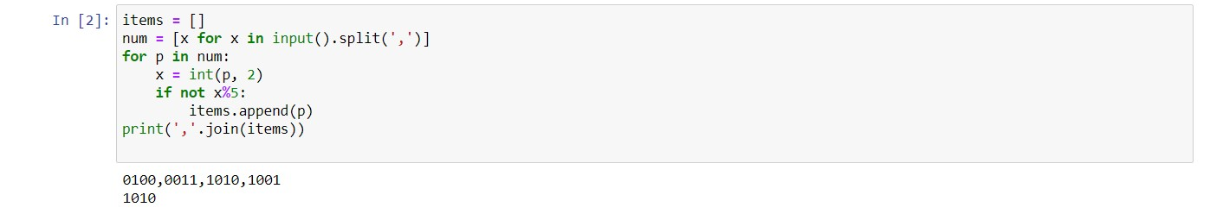

Write a program that accepts a sentence and calculate the number of letters and digits.

Suppose the following input is supplied to the program:

hello world! 123

Then, the output should be:

LETTERS 10

DIGITS 3

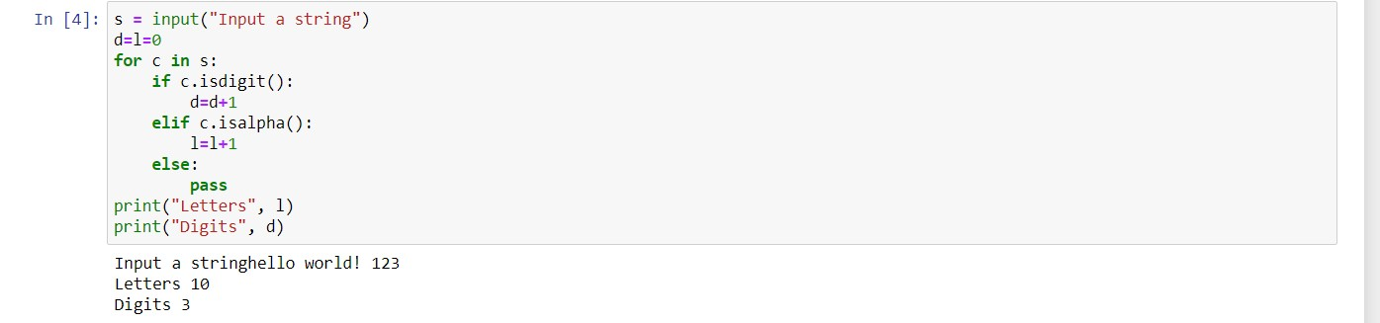

Write a program that accepts a sentence and calculate the number of upper case letters and lower case letters.

Suppose the following input is supplied to the program:

Hello world!

Then, the output should be:

UPPER CASE 1

LOWER CASE 9

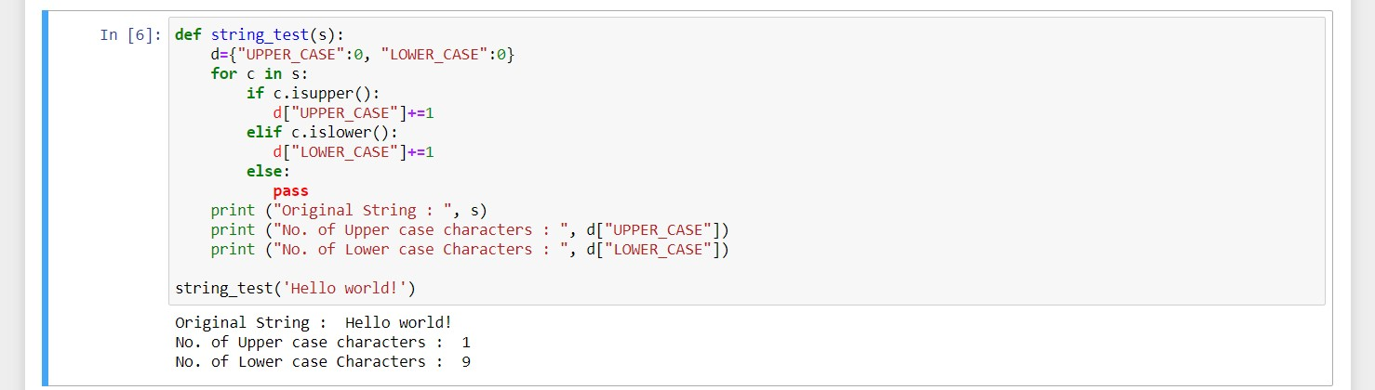

Write a program that computes the value of a+aa+aaa+aaaa with a given digit as the value of a.

Suppose the following input is supplied to the program:

9

Then, the output should be:

11106

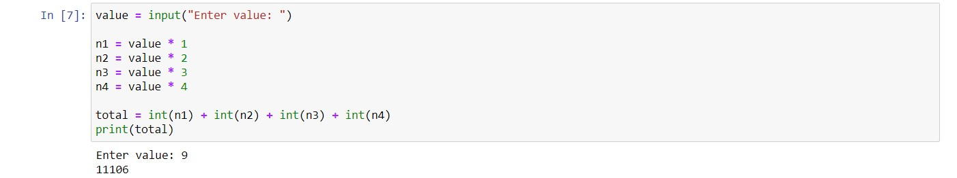

Write a program that computes the net amount of a bank account based a transaction log from console input. The transaction log format is shown as following:

D 100

W 200

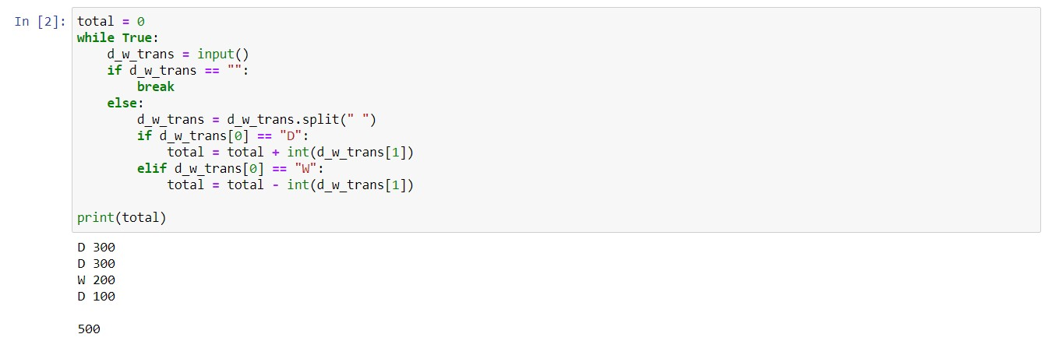

Define a function which can generate a list where the values are square of numbers between 1 and 20 (both included). Then the function needs to print the first 5 elements in the list.

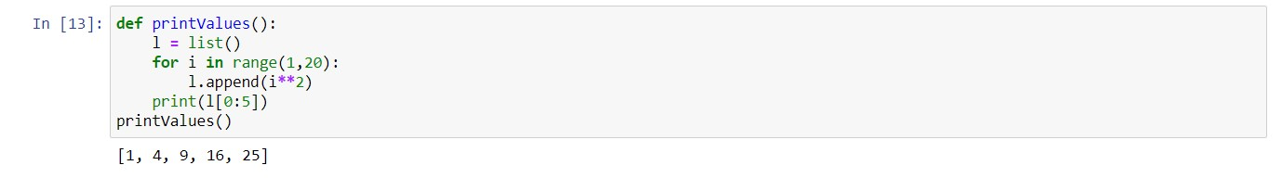

Define a function which can generate a list where the values are square of numbers between 1 and 20 (both included). Then the function needs to print the last 5 elements in the list.

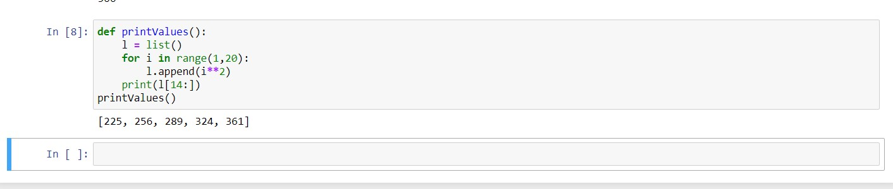

With a given tuple (1,2,3,4,5,6,7,8,9,10), write a program to print the first half values in one line and the last half values in one line.

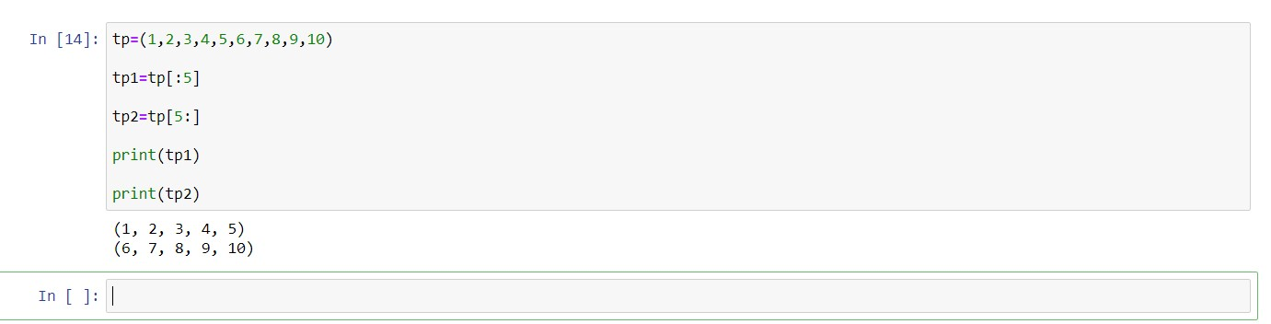

Write a program which can filter even numbers in a list by using filter function. The list is: [1,2,3,4,5,6,7,8,9,10].

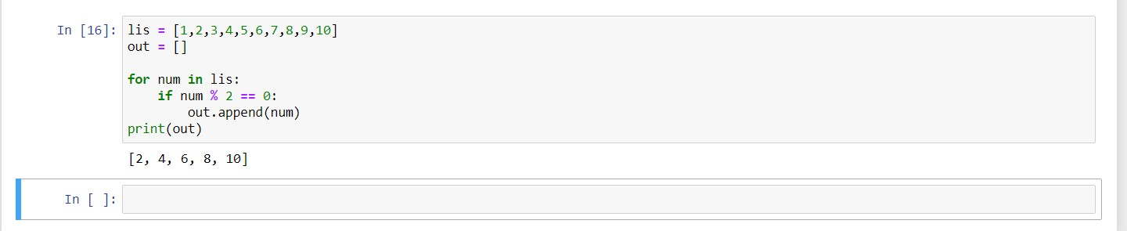

Define a function that can accept two strings as input and concatenate them and then print it in console.

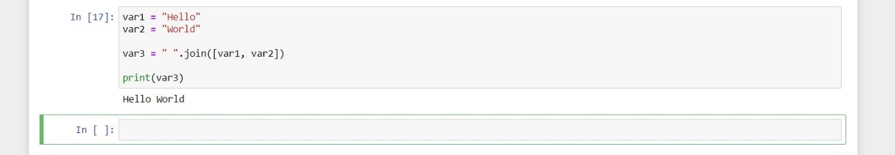

Define a function that can accept two strings as input and print the string with maximum length in console. If two strings have the same length, then the function should print al l strings line by line.

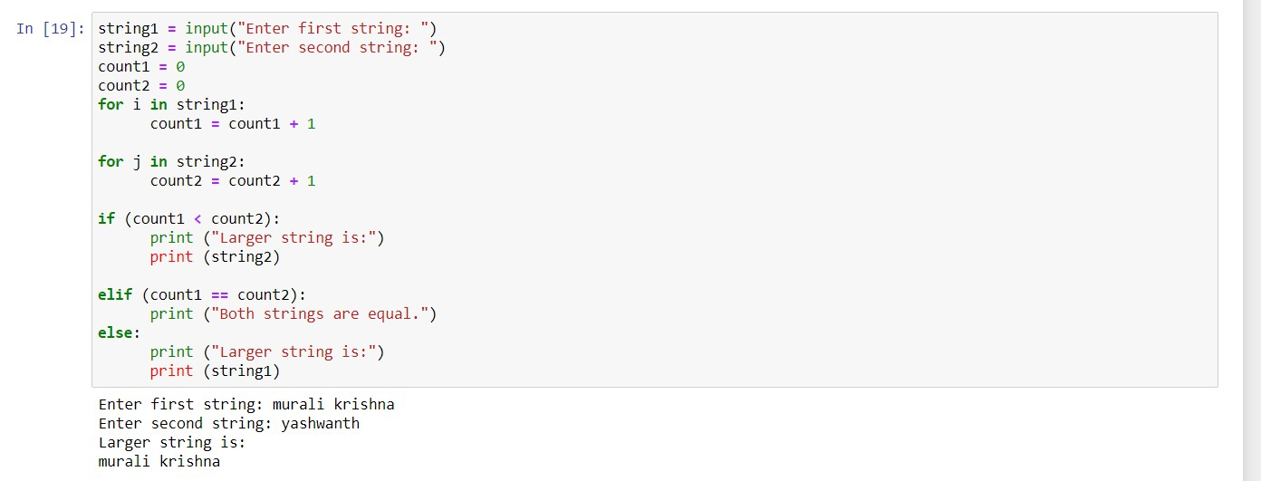

Define a function that can accept an integer number as input and print the "It is an even number" if the number is even, otherwise print "It is an odd number".

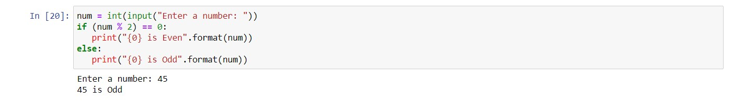

Please write a program which accepts a string from console and print the characters that have even indexes.

Example:

If the following string is given as input to the program:

H1e2l3l4o5w6o7r8l9d

Then, the output of the program should be:

Hello world

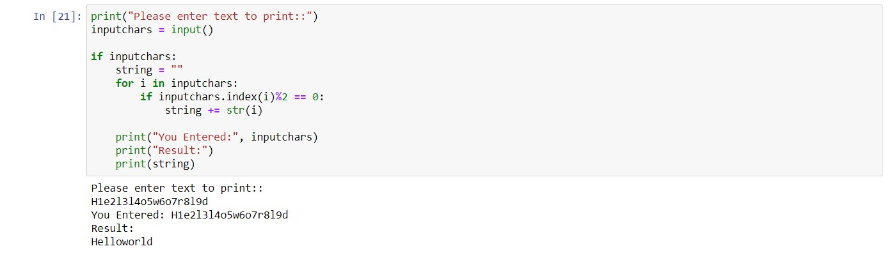

Please write a program which accepts a string from console and print it in reverse order.

Example:

If the following string is given as input to the program:

rise to vote sir

Then, the output of the program should be:

ris etov ot esir

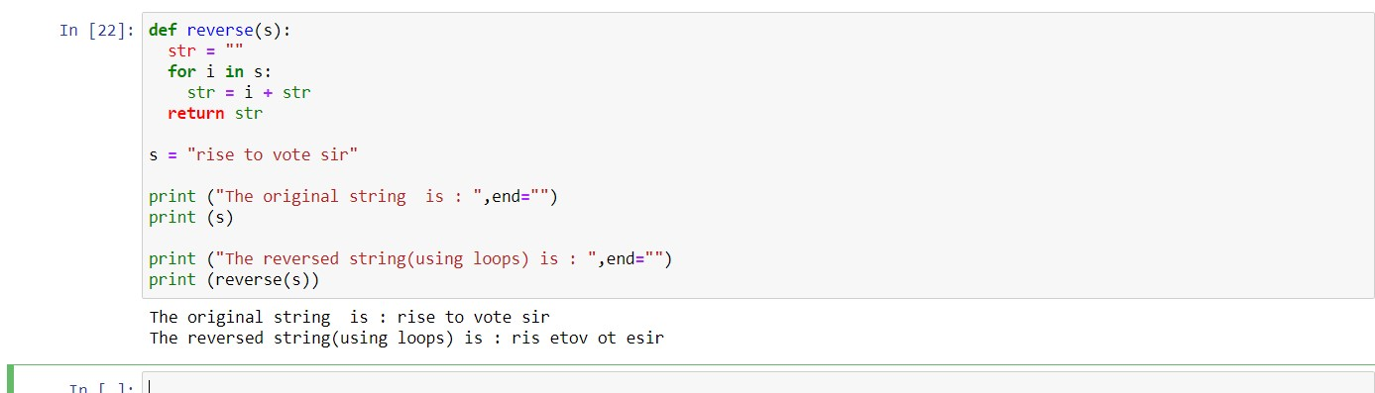

You are required to write a program to sort the (name, age, height) tuples by ascending order where name is string, age and height are numbers. The tuples are input by console. The sort criteria is:

1: Sort based on name;

2: Then sort based on age;

3: Then sort by score.

The priority is that name > age > score.

If the following tuples are given as input to the program:

Tom,19,80

John,20,90

Jony,17,91

Jony,17,93

Json,21,85

Then, the output of the program should be:

[('John', '20', '90'), ('Jony', '17', '91'), ('Jony', '17', '93'), ('Json', '21', '85'), ('Tom', '19', '80')]

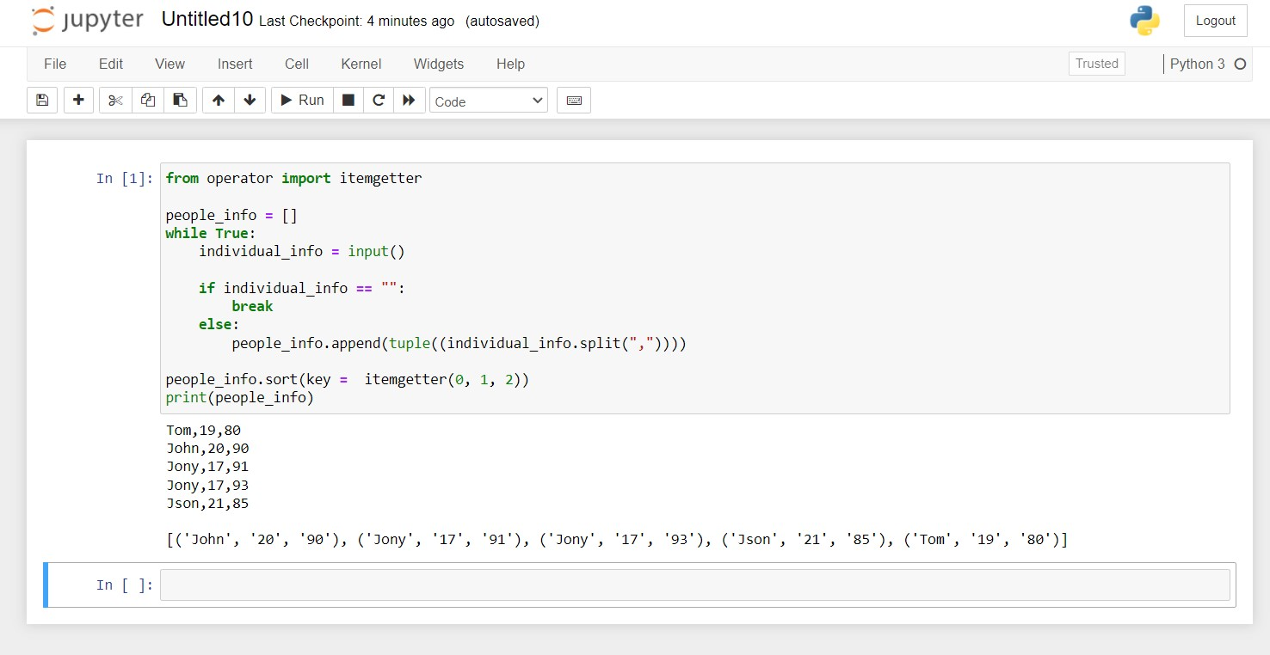

Define a class with a generator which can iterate the numbers, which are divisible by 7, between a given range 0 and n.

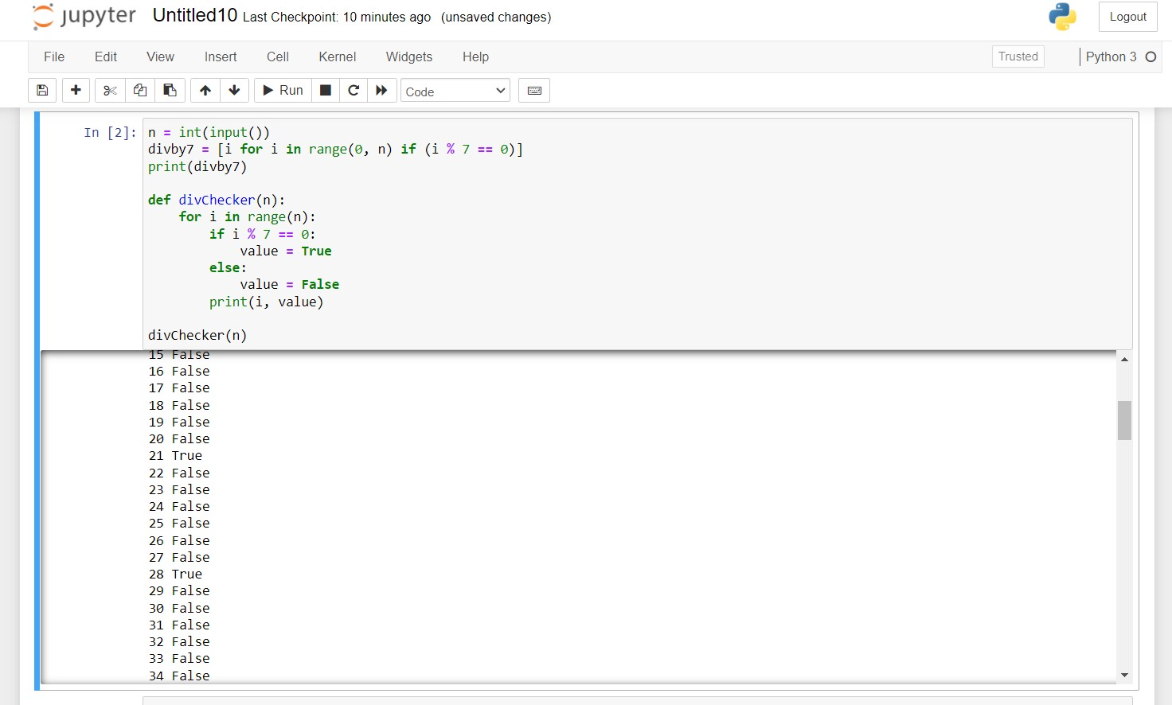

Write a program to compute the frequency of the words from the input. The output should output after sorting the key alphanumerically.

Suppose the following input is supplied to the program:

New to Python or choosing between Python 2 and Python 3? Read Python 2 or Python 3.

Then, the output should be:

2:2

3.:1

3?:1

New:1

Python:5

Read:1

and:1

between:1

choosing:1

or:2

to:1

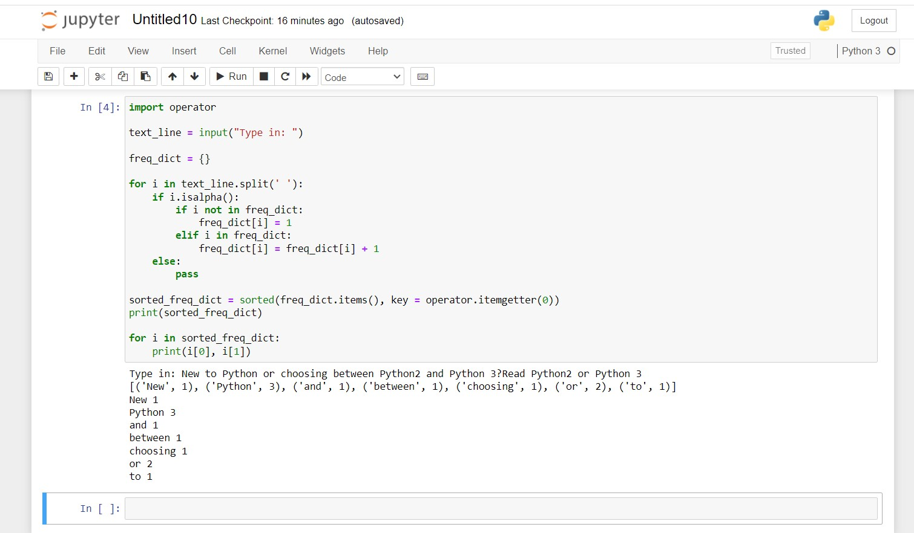

Write a method which can calculate square value of number

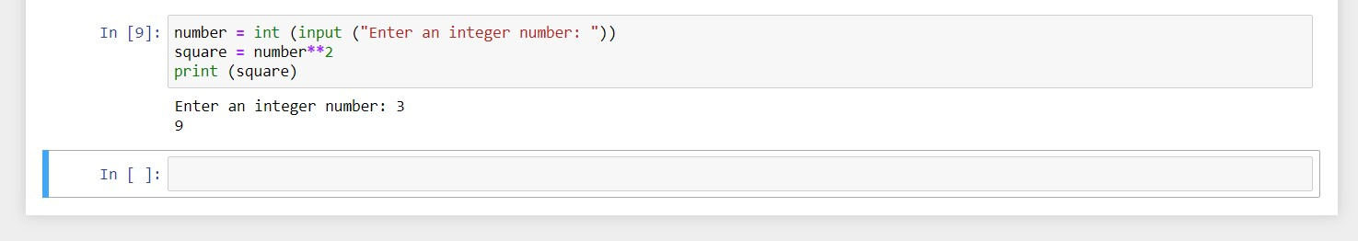

Define a function which can compute the sum of two numbers.

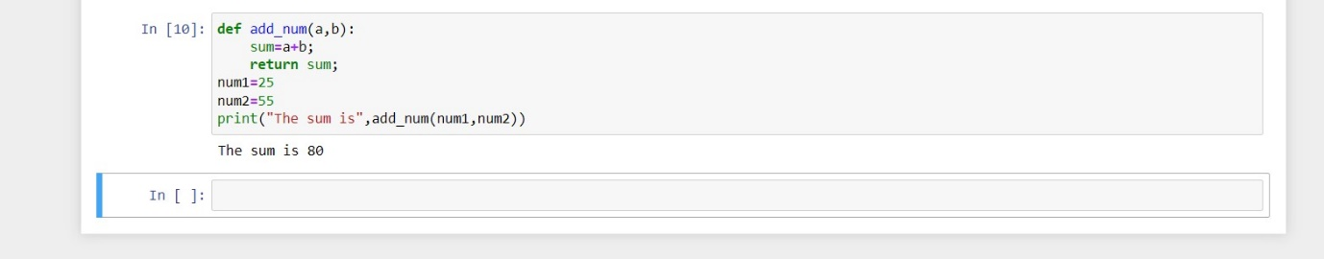

Define a class, which have a class parameter and have a same instance parameter.

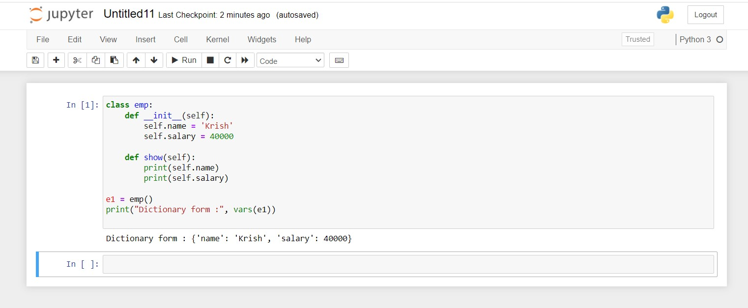

Define a function that can convert a integer into a string and print it in console

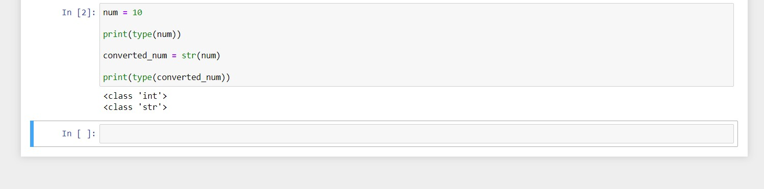

Define a function that can receive two integral numbers in string form and compute their sum and then print it in console.

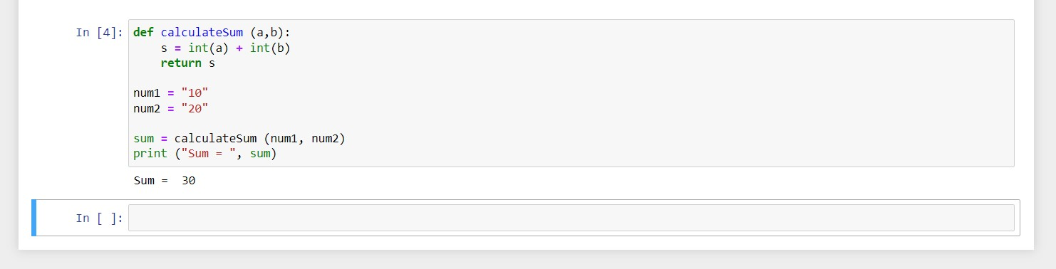

Define a function that can accept two strings as input and print the string with maximum length in console. If two strings have the same length, then the function should print al l strings line by line.

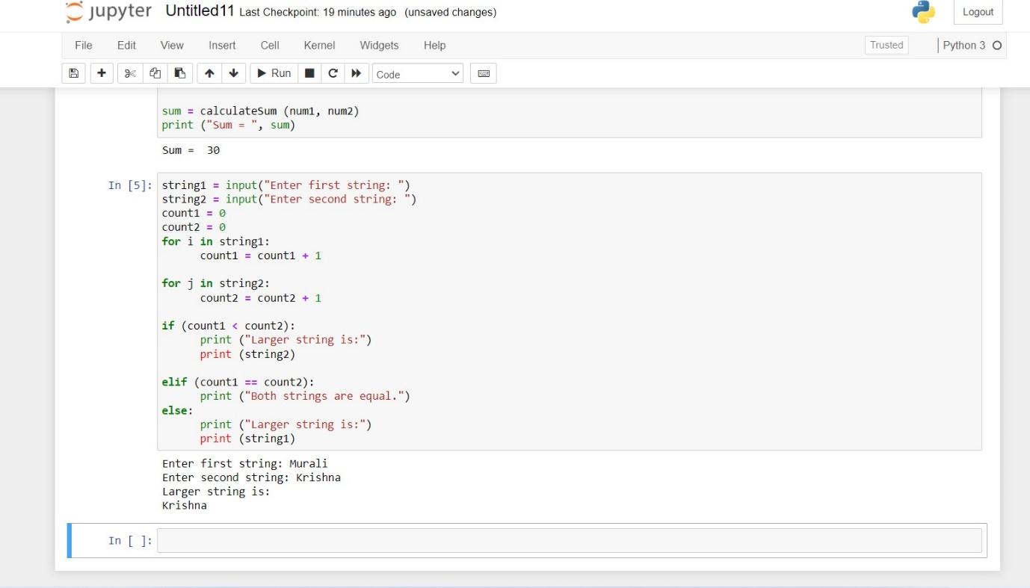

Define a function that can accept an integer number as input and print the "It is an even number" if the number is even, otherwise print "It is an odd number".

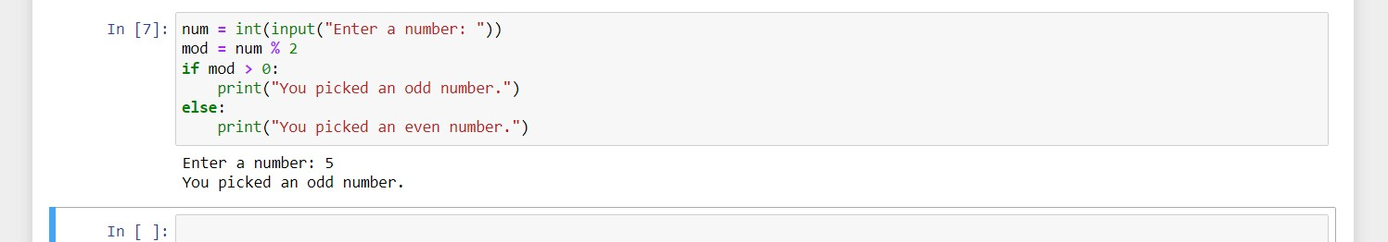

Define a function which can print a dictionary where the keys are numbers between 1 and 3 (both included) and the values are square of keys.

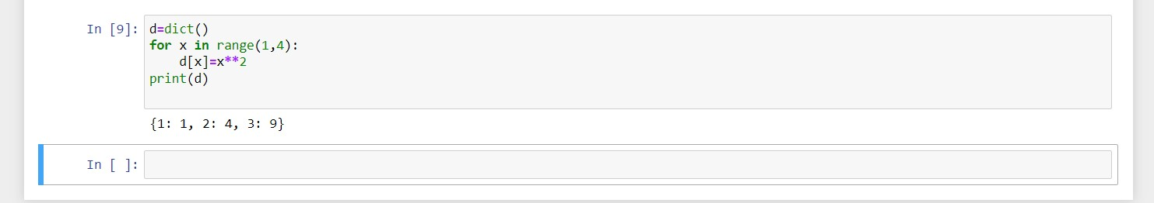

Define a function which can print a dictionary where the keys are numbers between 1 and 20 (both included) and the values are square of keys.

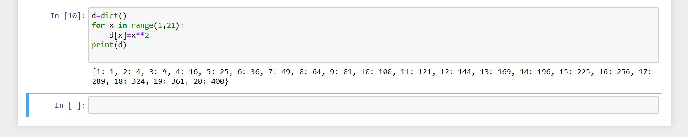

Write a program which can map() and filter() to make a list whose elements are square of even number in [1,2,3,4,5,6,7,8,9,10].



Write a program which can filter() to make a list whose elements are even number between 1 and 20 (both included)

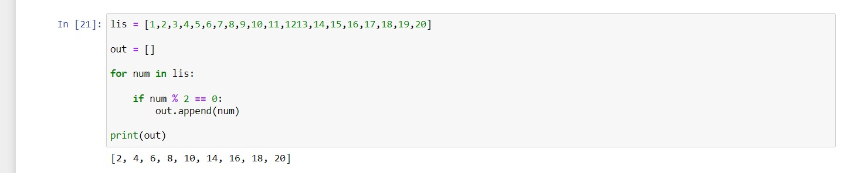

Define a class named American which has a static method called printNationality.

Hints:

Use @staticmethod decorator to define class static method.

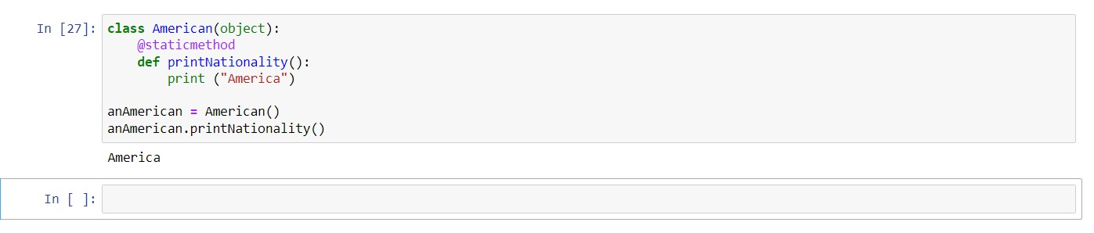

Define a class named American and its subclass NewYorker.

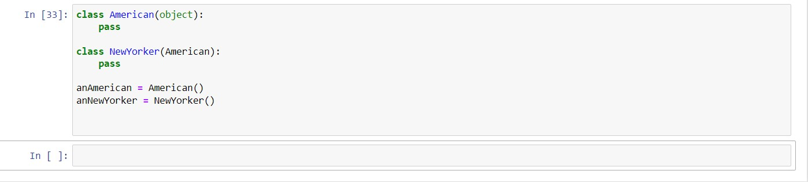

Define a class named Circle which can be constructed by a radius. The Circle class has a method which can compute the area.

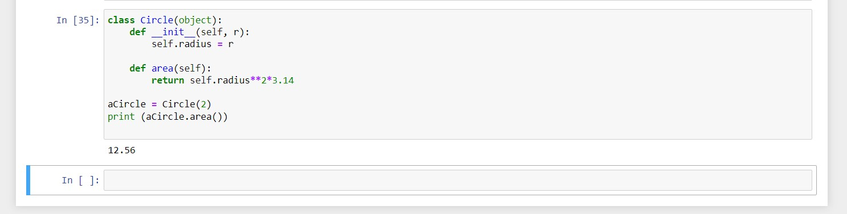

Define a class named Rectangle which can be constructed by a length and width. The Rectangle class has a method which can compute the area

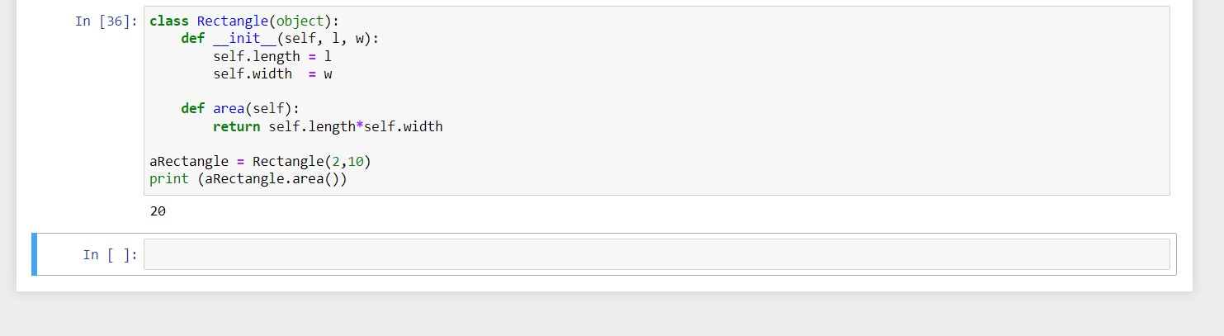

Define a class named Shape and its subclass Square. The Square class has an init function which takes a length as argument. Both classes have a area function which can print the area of the shape where Shape's area is 0 by default.

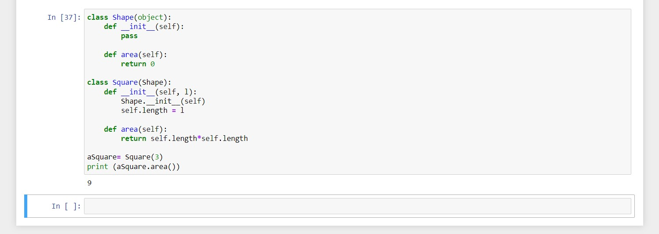

Define a class named Shape and its subclass Square. The Square class has an init function which takes a length as argument. Both classes have a area function which can print the area of the shape where Shape's area is 0 by default.

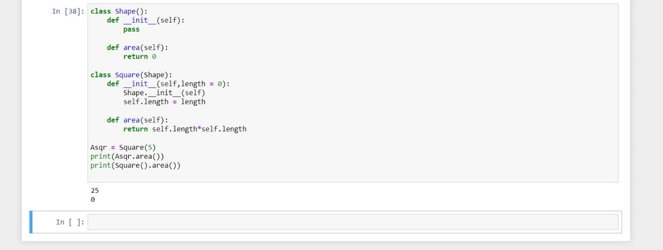

Write a function to compute 5/0 and use try/except to catch the exceptions

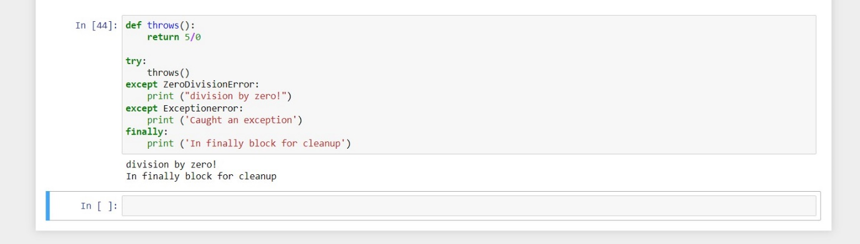

Print a unicode string "hello world".

Hints:

Use u'strings' format to define unicode string.

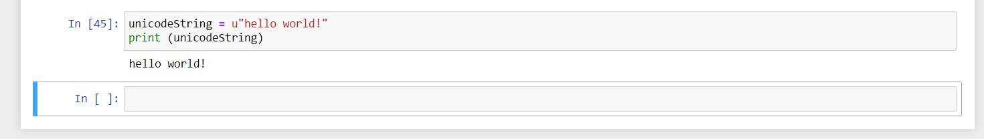

Write a program to compute 1/2+2/3+3/4+...+n/n+1 with a given n input by console (n>0).

Example:

If the following n is given as input to the program:

5

Then, the output of the program should be:

3.55

In case of input data being supplied to the question, it should be assumed to be a console input.

Hints:

Use float() to convert an integer to a float

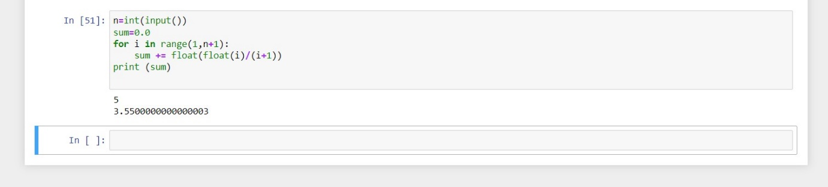

Write a program to compute:

f(n)=f(n-1)+100 when n>0

and f(0)=1

with a given n input by console (n>0).

Example:

If the following n is given as input to the program:

5

Then, the output of the program should be:

500

In case of input data being supplied to the question, it should be assumed to be a console input.

Hints:

We can define recursive function in Python.

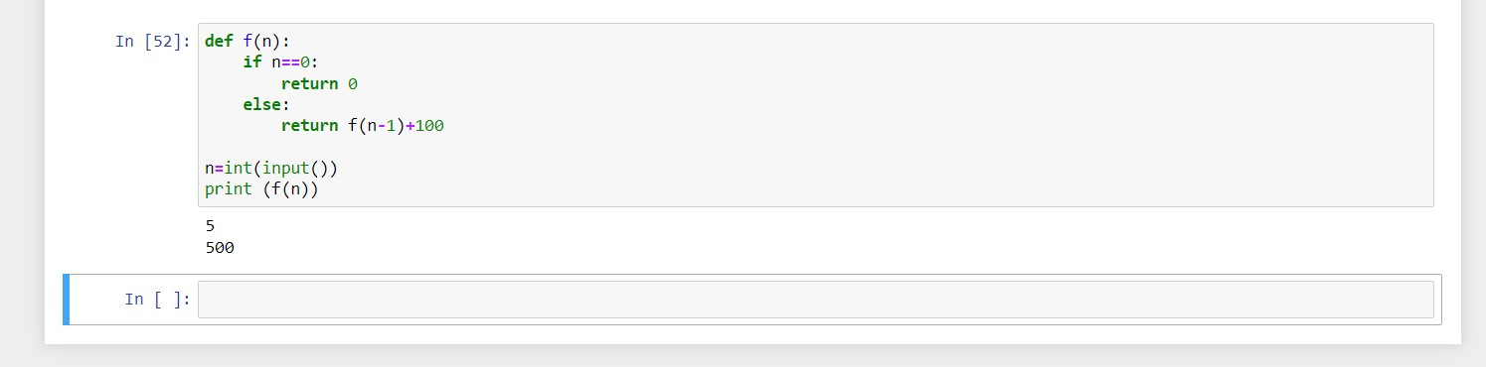

The Fibonacci Sequence is computed based on the following formula:

f(n)=0 if n=0

f(n)=1 if n=1

f(n)=f(n-1)+f(n-2) if n>1

Please write a program to compute the value of f(n) with a given n input by console.

Example:

If the following n is given as input to the program:

7

Then, the output of the program should be:

13

In case of input data being supplied to the question, it should be assumed to be a console input.

Hints:

We can define recursive function in Python.

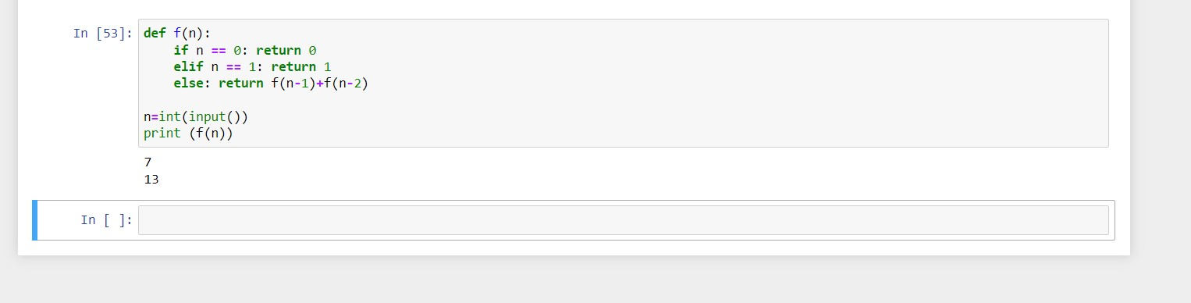

Please write assert statements to verify that every number in the list [2,4,6,8] is even.

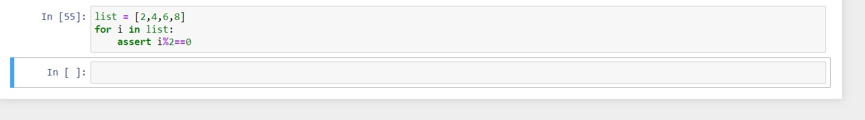

Please write a program which accepts basic mathematic expression from console and print the evaluation result.

Example:

If the following string is given as input to the program:

35+3

Then, the output of the program should be:

38

Hints:

Use eval() to evaluate an expression.

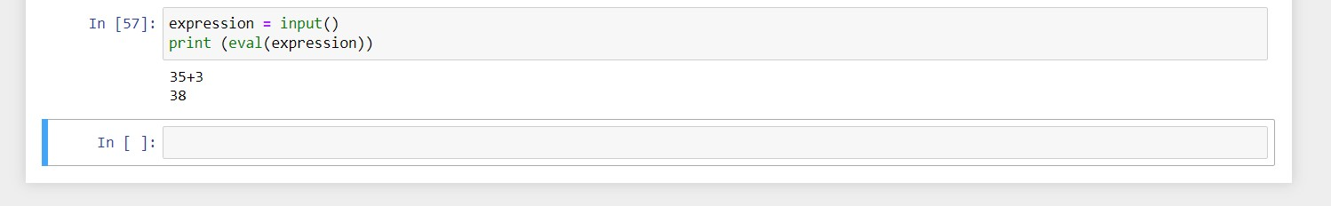

Please generate a random float where the value is between 10 and 100 using Python math module.

Hints:

Use random.random() to generate a random float in [0,1].

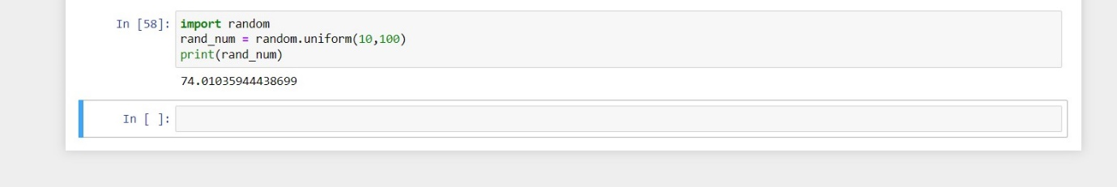

Please write a program to output a random even number between 0 and 10 inclusive using random module and list comprehension.

Hints:

Use random.choice() to a random element from a list.

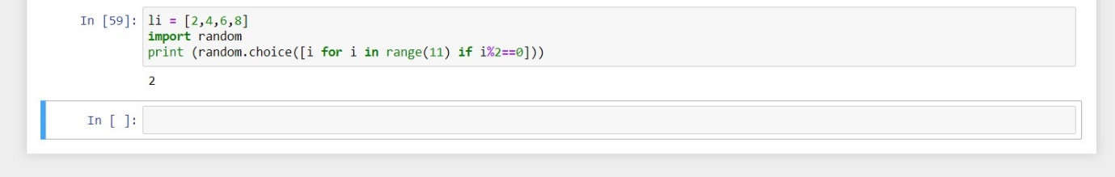

Please write a program to shuffle and print the list [3,6,7,8].

Hints:

Use shuffle() function to shuffle a list.

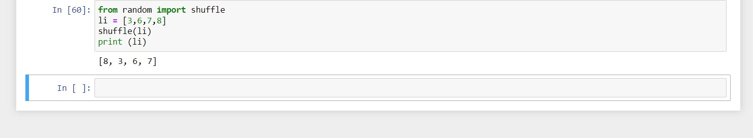

Please write a program to print the list after removing delete even numbers in [5,6,77,45,22,12,24].

Hints:

Use list comprehension to delete a bunch of element from a list.

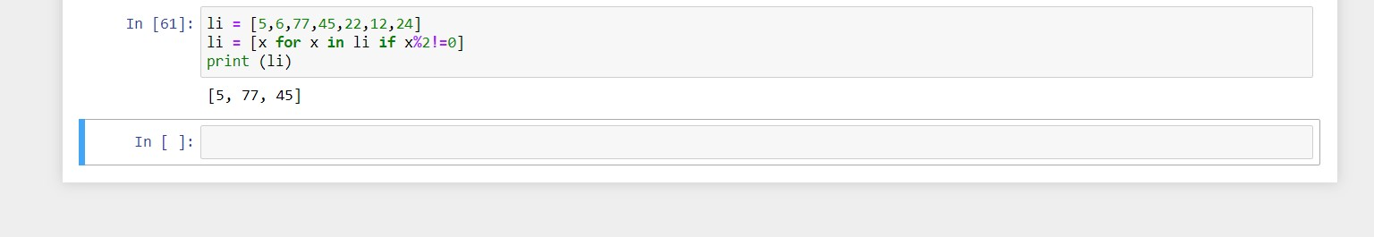

By using list comprehension, please write a program to print the list after removing delete numbers which are divisible by 5 and 7 in [12,24,35,70,88,120,155].

Hints:

Use list comprehension to delete a bunch of element from a list.

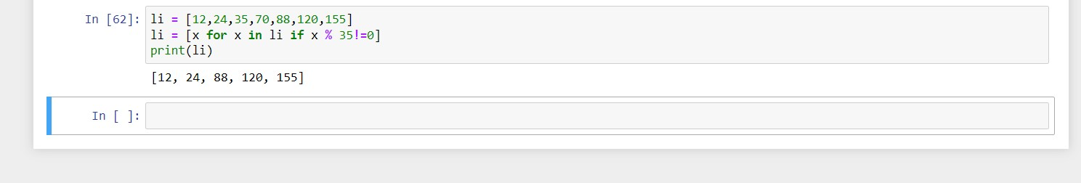

By using list comprehension, please write a program to print the list after removing the 0th, 2nd, 4th,6th numbers in [12,24,35,70,88,120,155].

Hints:

Use list comprehension to delete a bunch of element from a list.

Use enumerate() to get (index, value) tuple.

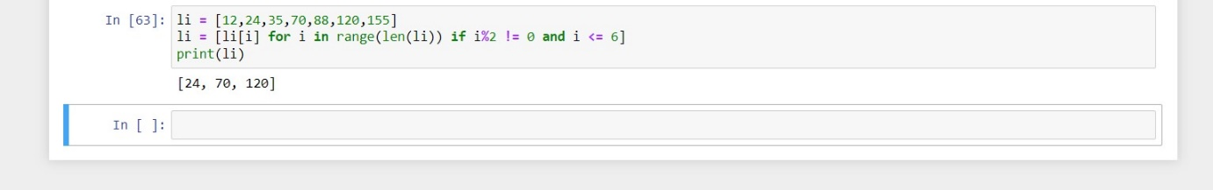

By using list comprehension, please write a program to print the list after removing the 0th,4th,5th numbers in [12,24,35,70,88,120,155].

Hints:

Use list comprehension to delete a bunch of element from a list.

Use enumerate() to get (index, value) tuple.

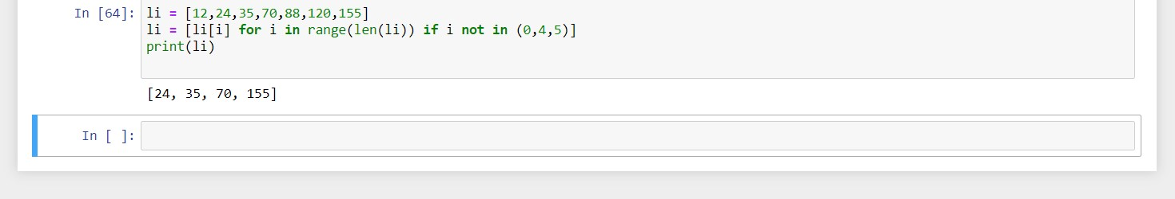

By using list comprehension, please write a program to print the list after removing the value 24 in [12,24,35,24,88,120,155].

Hints:

Use list's remove method to delete a value.

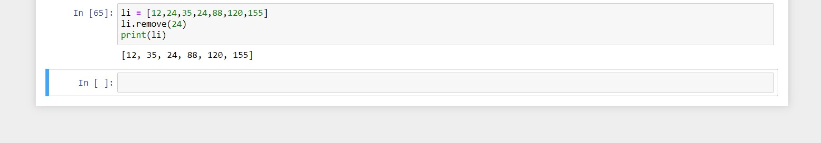

With two given lists [1,3,6,78,35,55] and [12,24,35,24,88,120,155], write a program to make a list whose elements are intersection of the above given lists.

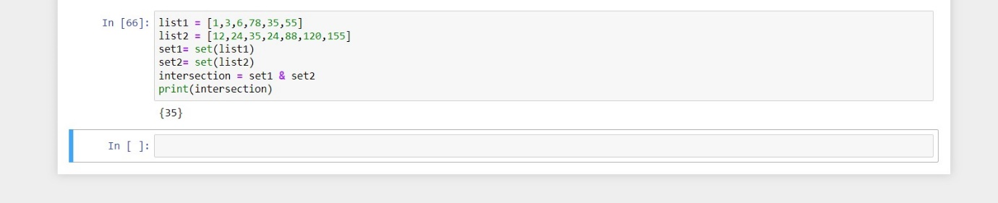

With a given list [12,24,35,24,88,120,155,88,120,155], write a program to print this list after removing all duplicate values with original order reserved.

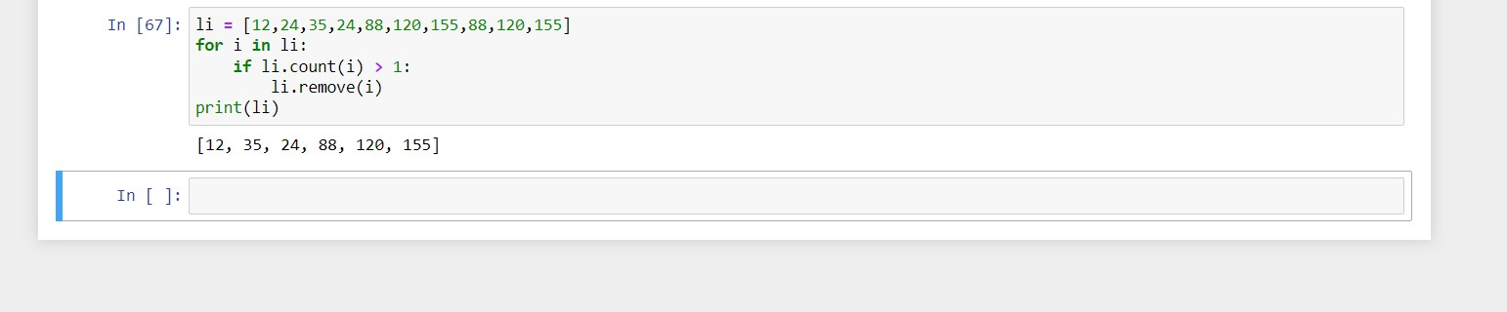

Define a class Person and its two child classes: Male and Female. All classes have a method "getGender" which can print "Male" for Male class and "Female" for Female class.

